**INDIAN INSTITUTE OF INFORMATION TECHNOLOGY, ALLAHABAD**

**Software Engineering**

Instructor: Abhishek Sir

SOFTWARE DESIGN SPECIFICATION

For

**SPOTR**



A PROFILE GENERATION

WEB APPLICATION

Group Members:

IIT2019127 MRIDUL MITTAL [iit2019127@iiita.ac.in](mailto:iit2019127@iiita.ac.in)

IIT2019145 PARAS AGRAWAL [iit2019145@iiita.ac.in](mailto:iit2019145@iiita.ac.in)

IIT2019146 KSHITIJ KUMAR [iit2019146@iiita.ac.in](mailto:iit2019146@iiita.ac.in)

IIT2019148 PIYUSH GURJAR [iit2019148@iiita.ac.in](mailto:iit2019148@iiita.ac.in)

1. **Introduction:**

“Spotr©” is basically a web application, which will help the user to trace the social media accounts across multiple platforms and the data is stored in the required database using SOCMINT techniques.

**1.1 Purpose:**

The process of searching the profile of a user across different platforms is a bit trivial, time-taking and less efficient.

From Social point of view,

* Have to search each and every social media site to trace the user
* The one searching have to have an account on the desired platform
* In case of urgency, it was difficult to trace the user at once
* Creating an account in each and every social media platform is hectic and a waste of time.

From Law point of view,

* Law officials have to look in every social media platform to search for evidence.
* Have to search for the number of posts which waste time of investigation
* In case of large database, it is very difficult to trace everyone at different social media platforms

So, this project is an attempt to overcome such challenges.

**1.2 Scope:**

We have described what features are in the scope of the software and what features are not in the scope of the software.

*In scope:*

1. Search user across various social media platforms
2. Can see the number of post made and like pages
3. Can extract profile information and other details which are visible publicly
4. Can store data in databases

*Out of scope:*

1. No communication via this application
2. Cannot see the hidden post or like pages

**1.3 Definitions, Acronyms, and Abbreviations:**

*Acronyms, and Abbreviations:*

* “Spotr©”: Copyrighted app name.
* SRS: Software Requirement Specification
* SOCMINT: SOCial Media INTelligence

*Definitions:*

* SOCMINT: SOCMINT is a subclass of OSINT framework where it refers to any information that can legally be gathered from social media (facebook, twitter, instagram, Linkedin, Github) about an individual or organization.
* “Spotr©”: A web application for tracing the user across various social media platforms by taking username as input and storing the information in the database.

**1.4 References:**

IEEE SRS format

**1.5 Overview:**

The rest of this SRS is organized as follows: Section 2 gives an overall description of the software. It gives what level of proficiency is expected of the user, some general constraints while making the software and some assumptions and dependencies that are assumed. Section 3 gives specific requirements which the software is expected to deliver. Functional requirements are given by various use cases. Some performance requirements and design constraints are also given

1. **Overall Description:**

**2.1 Product Perspective:**

“Spotr©” is aimed to increase the efficiency of tracing the user profile across various social media platforms and overcome the challenges as mentioned above. One-Click feature of the app will help save a lot of time from tracing the various social media platforms. Overall, this application will trace the user profile, can extract information and can store the required data in the database.

**2.2 Product Functions:**

“Spotr©” supports the following use cases:

|  |  |  |  |
| --- | --- | --- | --- |
| **S.No.** | **USE CASE** | **DESCRIPTION** | **SHOWN** |
|  | **User:** |  |  |
| 1. | User Login | Allows user to login on platform using the  credentials | Done |
| 2. | Invalid Password | Username/Password Authentication | Done |
| 3. | Search Username | Allows user to search profile based on the username | Done |
| 4. | Linkedin Profile | Allows user to see information of that username on the basis of LinkedIn data | Done |
| 5. | Twitter Profile | Allows user to see information of that username on the basis of Twitter data | Done |
| 6. | Instagram Profile | Allows user to see information of that username on the basis of Instagram data | Done |
| 7. | Facebook Profile | Allows user to see information of that username on the basis of Facebook data | Done |
| 8. | Github Profile | Allows user to see information of that username on the basis of Github data | Done |
| 9. | Platform details |  | Done |
| 10. | Show Profile | Redirect user to the platform profile of the username | Done |
| 11. | Platform login / signup | User must be logged in to all the platforms to view profiles of other people | Done |
| 12. | Data Scraping | Search for data of the user from the profile page of the platform | Done |
| 13. | Sentiment Analysis | Deduce relevant information about the user from the profile page and predicting sentiments using trained ML models | Done |
| 14. | Data Storage | The received data of the user based on username  from various profile is stored in the database | Done |

**2.3 User Characteristics:**

The user should be familiar with the operations of web applications.

**2.4 Principal Actor:**

The principal actor in “Spotr©” is ***USER.***

**2.5 General Constraints:**

1. Working on “Spotr©” requires Internet connection.
2. “Spotr©” is a single-user application. Every user must have this web application on their end to use the features.

**2.6 Assumptions and Dependencies:**

1. Working on “Spotr©” is dependent on the availability of Internet connectivity.
2. USER must have to enter all the required information for accessing the application

## 

## **APPENDIX A: USE CASE DIAGRAM**

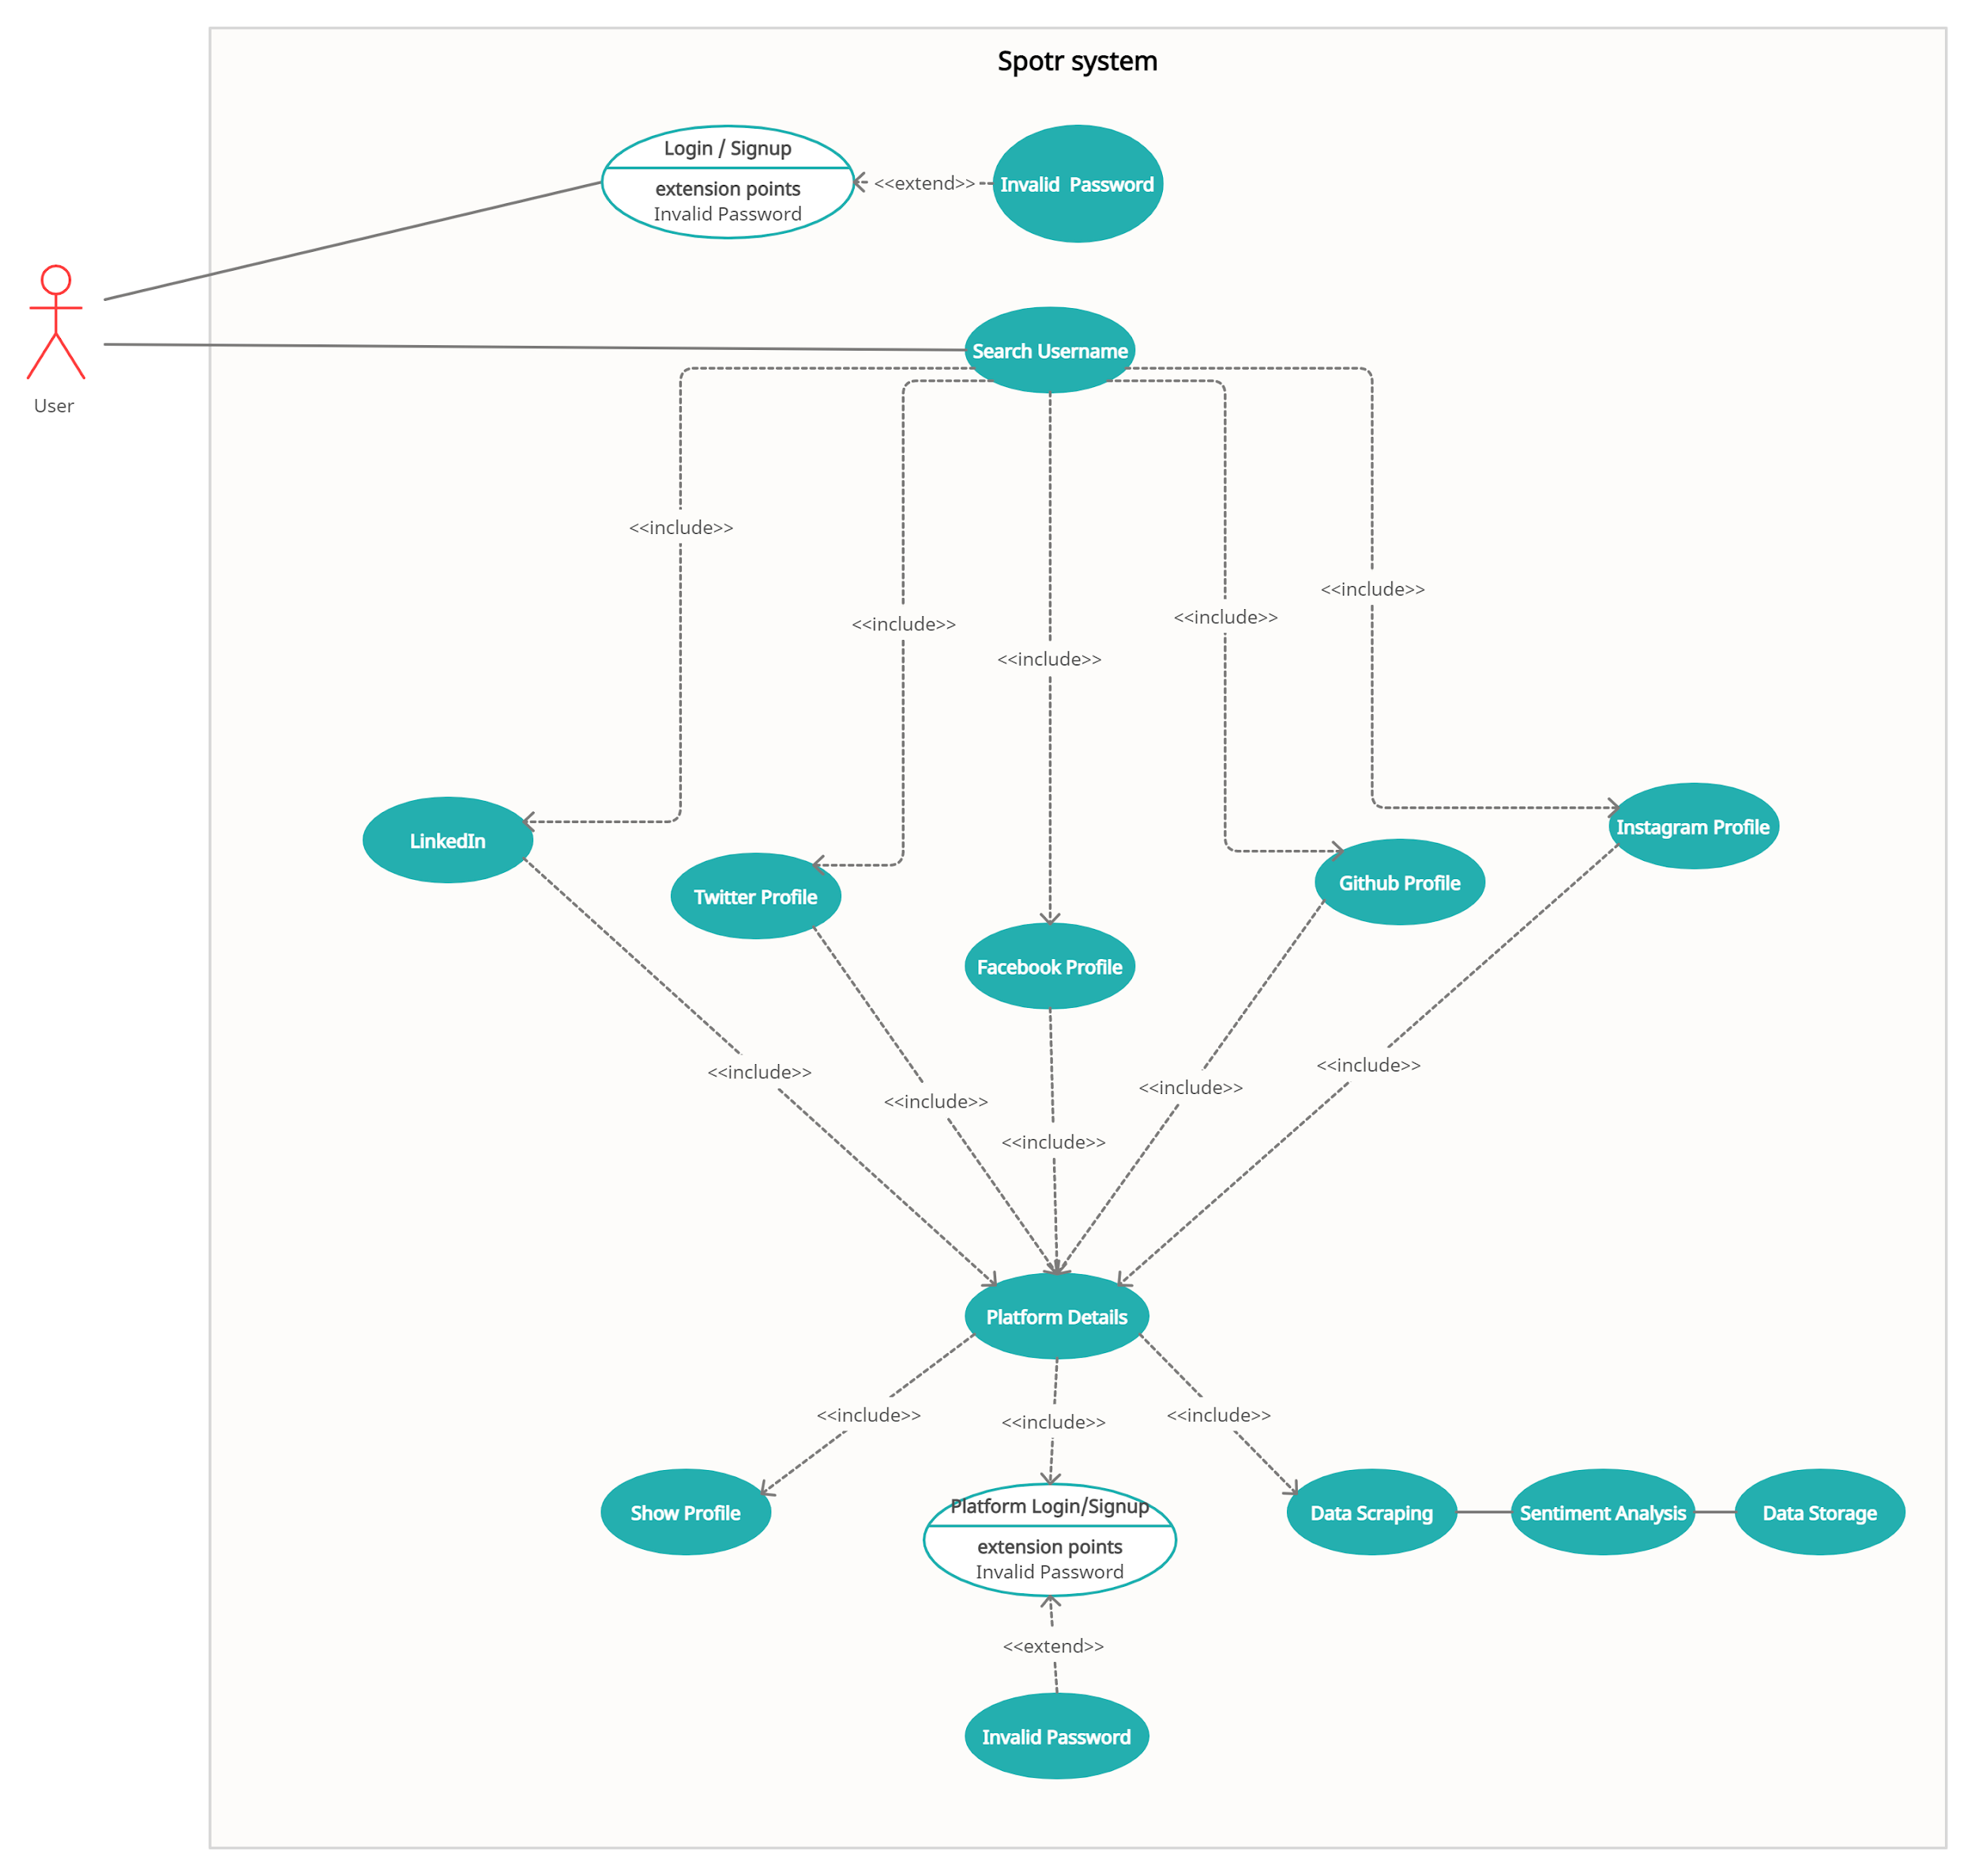

1. **Specific Requirements:**

**3.1: Functional Requirements:**

We describe the functional requirements by giving various use cases.

**USE CASE 1:**

**Name:** User Login

**Description:** Allows User to login.

**Actors:** User

**Pre-conditions:**

* Internet connectivity.
* Only for allowed username and password

**Main success scenario:**

* User enters credentials and clicks on the login button.
* Spotr checks for the validity of the credentials.

**Extension:**

Id or Password incorrect. Error message is displayed.

**Post-condition:**

User can now access all features of the Spotr.

**USE CASE 2:**

**Name:** Search username

**Description:** Allows user to search profile based on the username

**Actors:** User

**Pre-conditions:**

* Logged in

**Main success scenario:**

* User enters username and clicks on the search button.

**Extension:**

Invalid username. No searching is performed.

**Post-condition:**

Users can now access all profiles available with the given username.

**USE CASE 3:**

**Name:** Facebook Profile

**Description:** Allows user to see information of that username on the basis of Facebook data

**Actors:** User

**Pre-conditions:**

* Logged in
* Searched username exists on Facebook

**Main success scenario:**

* The data of the username is viewed

**Extension:**

NIL

**Post-condition:**

Users can now access the facebook data of the username provided

(SAME USE CASE FOR DIFFERENT SOCIAL MEDIA PLATFORMS)

**USE CASE 4:**

**Name:** Data Scraping

**Description:** Search for data of the user from the profile page of the platform .

**Actors:** User

**Pre-conditions:**

* Username profile exists
* Entered the social media account of that user

**Main success scenario:**

* Data is retrieved from the platform

**Extension:**

Sentiment Analysis can be performed on the retrieved data

**Post-condition:**

The data can be viewed by the user

**USE CASE 5:**

**Name:** Sentiment Analysis

**Description:** Deduce relevant information about the user from the profile page and predicting sentiments using trained ML models

**Actors:** User

**Pre-conditions:**

* Data is successfully retrieved from the platform

**Main success scenario:**

* Data is ready to be stored in the database

**Extension:**

Data Storage

**Post-condition:**

Spotr will pass the data for storage

**USE CASE 6:**

**Name:** Data Storage

**Description:**The received data of the user based on username

from various profile is stored in the database

**Actors:** User

**Pre-conditions:**

* Data is successfully retrieved from the platform

**Main success scenario:**

* Data is stored in the database for future use

**Extension:**

Data is ready to be stored in the database

**Post-condition:**

Spotr will store the data in the database

**3.2: Non-Functional Requirements:**

* **Product requirements:**
  + The web application must have a simple, user-friendly interface so customers can save time and confusion.
  + The website shall be functional for 24*7
  + The app must load between 2-4 seconds, for fast and effective responses.
  + Data should be saved in case of any failure.
* **Security Requirements:**
  + Only registered users can access the web application
  + Back-end servers or databases should only be accessed by the website management.
* **External Requirements:**
  + A modern web browser to access all the features of the website without facing any issue.